|  |  |  |
| --- | --- | --- |
|  | Mandurama Public School Newsletter  Loquat St, MANDURAMA NSW  Ph. 02 6367 5103 Principal (R) Mrs Karen Brill | Week 3 Term 2 2020  C:\Users\kbrill\Pictures\Home - Mandurama Public School_files\img_2131_1376018885069_l.jpg |

Dear families,

We have all returned to the “new normal” at our wonderful school and the children are all working hard to improve their knowledge and skills. Now that it is Term 2, our Nature Reserve is open at lunchtimes for the students and they have certainly been making the most in this beautiful natural environment.

Next Friday, 22nd May the children are encouraged to “dress like a pirate” and to bring in a gold coin to help the search for a cure for childhood Brain Cancer. On this day we will also be making some pirate food such as “dead man’s fingers” and “sword kebabs” so the children won’t need to bring lunch on that day.

Finally can I thank the staff, parents and children of our wonderful school for the co-operation in keeping our school safe. We are fortunate to have 2 hours of extra cleaning per day and have been very conscientious with our hygiene.

I encourage you all to keep yourselves safe, keep moving and eat well in these challenging times.

Until then – AHOY THERE ME HARDIES!

Mrs Brill Principal (R)

*With kind regards,*

*Mrs Brill Principal (R)*

**Coming Up!**

Week 4 Friday 22nd May PIRATE DAY

Week 5 Thursday 26th May CAMPFIRE COOKOUT – weather permitting - Help needed

Week 6 Tuesday 2nd June Pyjama Day – (Gold Coin donation)

Week 7

MONDAY 8th June

QUEENS BIRTHDAY

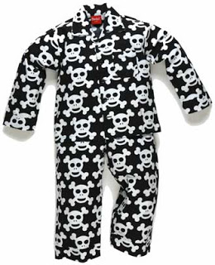

*Congratulations to Clint who was the student closest to the 278 jelly beans in this jar. WOW – looks can be deceptive. We were still almost 100 off what we thought was in there!*

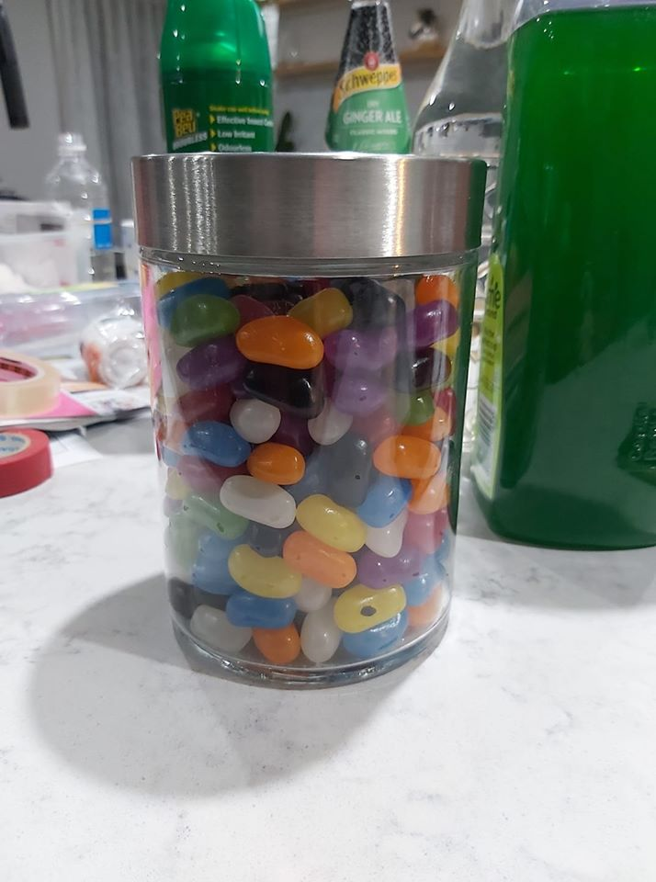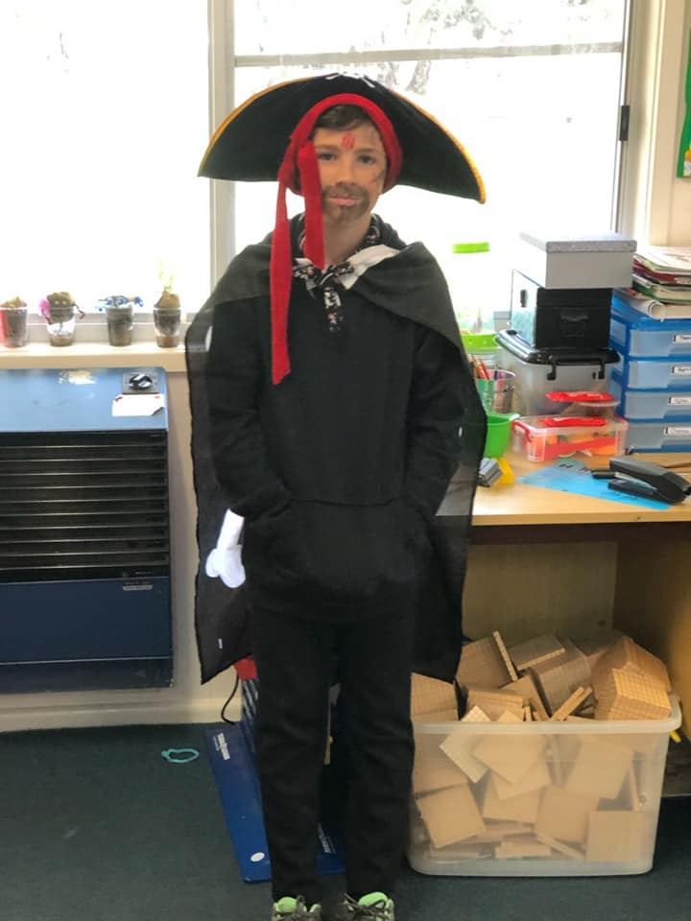

|  |  |
| --- | --- |
| STUDENT IN FOCUS*iSABELLA* https://scontent-syd2-1.xx.fbcdn.net/v/t1.15752-9/s2048x2048/97842850_2698678757018327_9173807585977958400_n.jpg?_nc_cat=106&_nc_sid=b96e70&_nc_ohc=dYZZ1eRz4AQAX8n8ODb&_nc_ht=scontent-syd2-1.xx&_nc_tp=7&oh=808c418a150c52cf0ab253338d607402&oe=5EE084BD *Isabella has been reading The Very Hungry Caterpillar, almost by herself. She is now writing her own book about The Very Hungry Girl. Did you know that little girls aren’t grown in eggs like caterpillars? Well done Isabella in Kindergarten. We look forward to the next pages that you write about what the little girl ate every day.*  **Mandurama Public School Vision Statement**  *We are committed to a high expectations, quality learning environment with a focus on collaboration and inclusiveness so that every child is a successful learner and citizen.*  Here are some examples of quality learning at our school. Image may contain: one or more people and foodImage may contain: 1 person, standingImage may contain: one or more people, tree, sky, outdoor and nature | |
|  | |
|  |  |